KMC Theme Weeks
We will have designated weeks each month where dancers can break the dress code and we can have a little fun ! Look for reminders of these weeks on Facebook and Instagram. E-mail reminders will also be sent out and the weeks will be posted on the website.
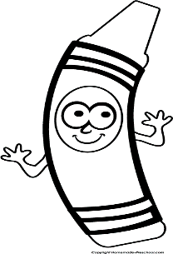
Monday Sept 25th -Saturday October 30th What’s Your Favorite Color Week!
Purple, Yellow, Pink or Blue..what color looks best on YOU!?
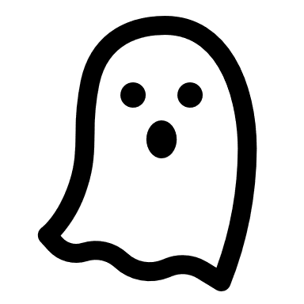
Monday Oct. 24th-Saturday October 30th Halloween Week!
Dancers in Monday, Thursday and Saturday Classes may wear their Halloween costumes to class. Tuesday and Wednesday night dancers can wear Halloween themes shirts/leggings etc. ALL dancers can bring a treat to share with their classmates.
Wednesday November 13th-Tuesday November 18th PJ Week!
Dancers can wear their PJ’s to dance class.
Saturday December 16th-Thursday December 21st Find your Inner ELF!
Dancers can wear all the jingle bells, sparkles, glitter etc.. that they want ! Christmas sweaters/shirts/leggings too. Dancers can dress as much Christmas spirit as they want
Monday January 15th -Saturday January 20th Crazy Socks/Hair !
Silly socks or silly hair...Do both if you dare !

Monday February 19th -Saturday February 24th Summer Fun Week !
Anticipating the dread of the long winter months, we encourage dancers to wear beach type clothing to class. Baseball/beach hats, shorts, sunglasses, Hawaiian shirts etc..
Monday March 18th -Saturday March 23rd KMC Spirit Week!
Show your KMC pride with your KMC attire or red/black/white !

Monday April 22nd -Saturday April 27th School/Team Spirit Week!
Dress in your school colors or wear clothing to show spirit for your favorite sports team!

